***Chemistry***

**14: Acid-Base Equilibria**

**14.5: Polyprotic Acids**

81. Which of the following concentrations would be practically equal in a calculation of the equilibrium concentrations in a 0.134-*M* solution of H2CO3, a diprotic acid: , [OH–], [H2CO3], , ? No calculations are needed to answer this question.

Solution

 and  are equal in a 0.134-*M* solution of H2CO3. *K*a of H2CO­3 is significantly larger than *K*a for . Therefore, very little of  ionizes to give hydronium ions and  ions, and the concentrations of  and  are practically equal in an aqueous solution of H2CO3.

83. Calculate the concentration of each species present in a 0.010-*M* solution of phthalic acid, C6H4(CO2H)2.



Solution

[C6H4(CO2H)2] 7.2 × 10–3*M*, [C6H4(CO2H)(CO2)–] =  2.8 × 10–3*M*, 3.9 × 10–6*M*, [OH–] 3.6  10–12*M*]

85. The ion HTe– is an amphiprotic species; it can act as either an acid or a base.

(a) What is *K*a for the acid reaction of HTe– with H2O?

(b) What is *K*b for the reaction in which HTe– functions as a base in water?

(c) Demonstrate whether or not the second ionization of H2Te can be neglected in the calculation of [HTe–] in a 0.10 *M* solution of H2Te.

Solution

(a) as an acid,

;

(b) as a base,

;

(c) The reactions and ionization constants are:



As a general rule, if the first ionization constant is larger than the second by a factor of at least 20, then the second ionization can be neglected. Sinceis 230-times largerthan, the assumption should hold true for HTe–. To test the assumptions, find [HTe–] from the first reaction. The equilibrium expression for this reaction is .

The initial and equilibrium concentrations for this system can be written as follows:

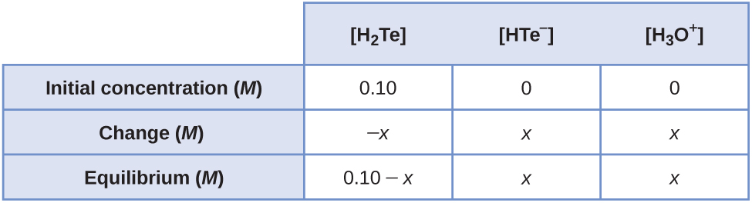

Substituting the equilibrium concentrations into the equilibrium expression, and making the assumption that (0.10 – *x*) ≈ 0.10, gives .

Solving for *x* gives 0.0152 *M*. Because this value is 15% of 0.10 *M*, our assumption is incorrect. Therefore, use the quadratic formula. Using the data gives the quadratic equation:

*x*2 + 2.3  10–3*x* – 2.3  10–4 = 0

Using the quadratic formula gives (*a* = 1, *b* = 2.3  10–3, and *c* = –2.3  10–4)



Thus [HTe–] = 0.014 *M*. For the second ionization, .

The initial and equilibrium concentrations for this system can be written as follows:

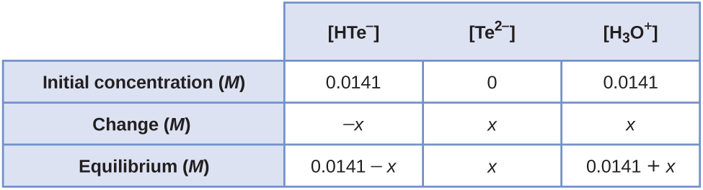

Substituting the equilibrium concentrations into the equilibrium expression, and making the assumptions that (0.0140 – *x*) ≈ and (0.0141 + *x*) ≈ 0.0141, gives:



Solving for *x* gives 1  10–5 *M*. Therefore, compared with 0.014 *M*, this value is negligible (0.071%).

This resource file is copyright 2015, Rice University. All Rights Reserved.